1. Install Python3.9

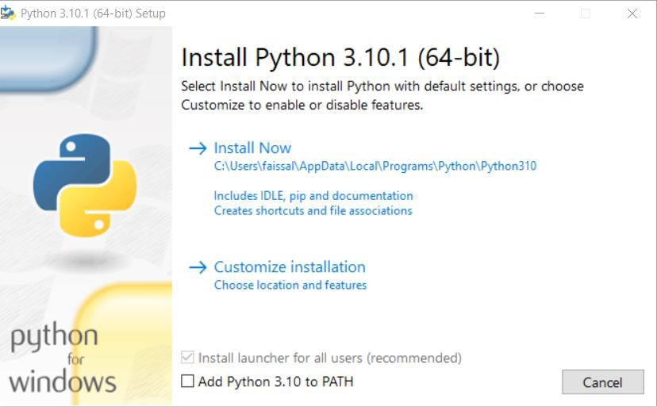

1-1-Check Add Python To Path

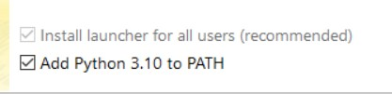

1-2-Click install

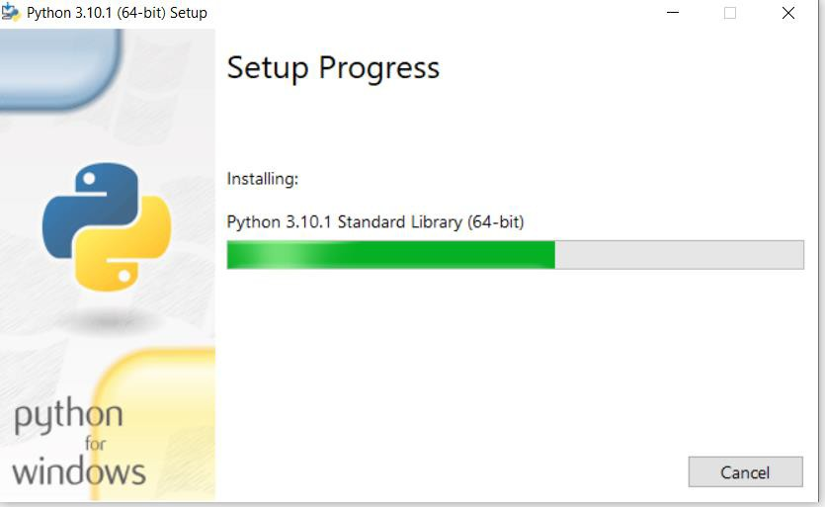

1. Check if python is added to path or not 2-1-open windows settings

2-2 click on system icon 2-3 click on about

2-4 click on advanced system settings under Related settings

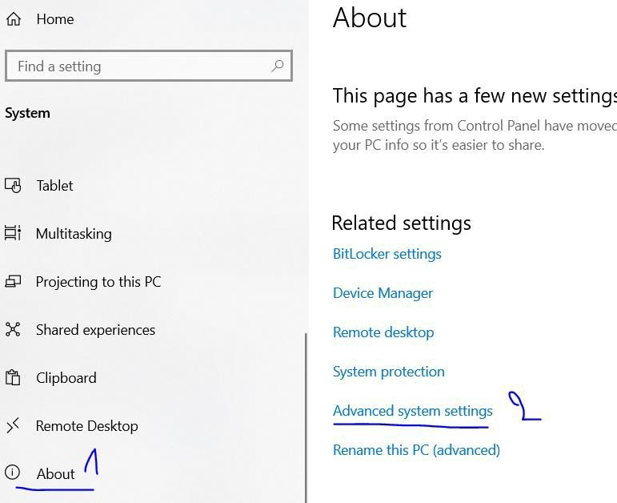

Or

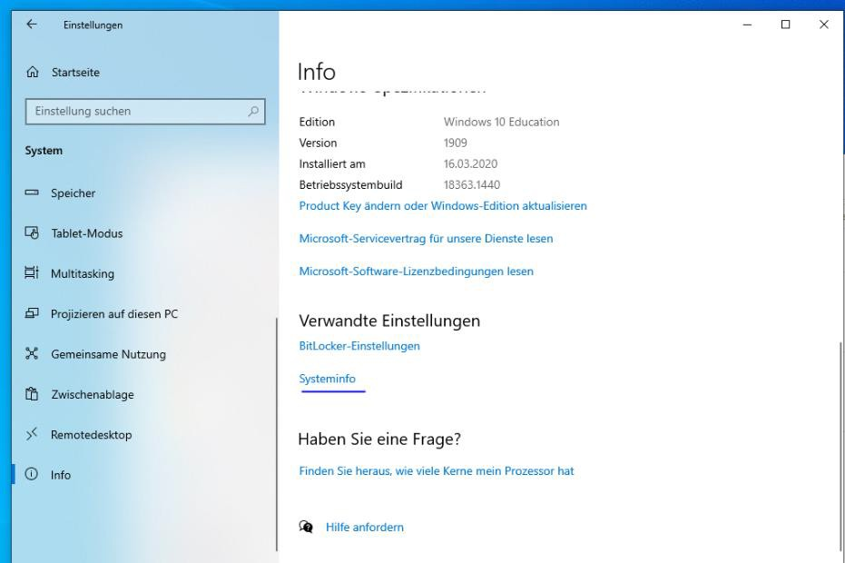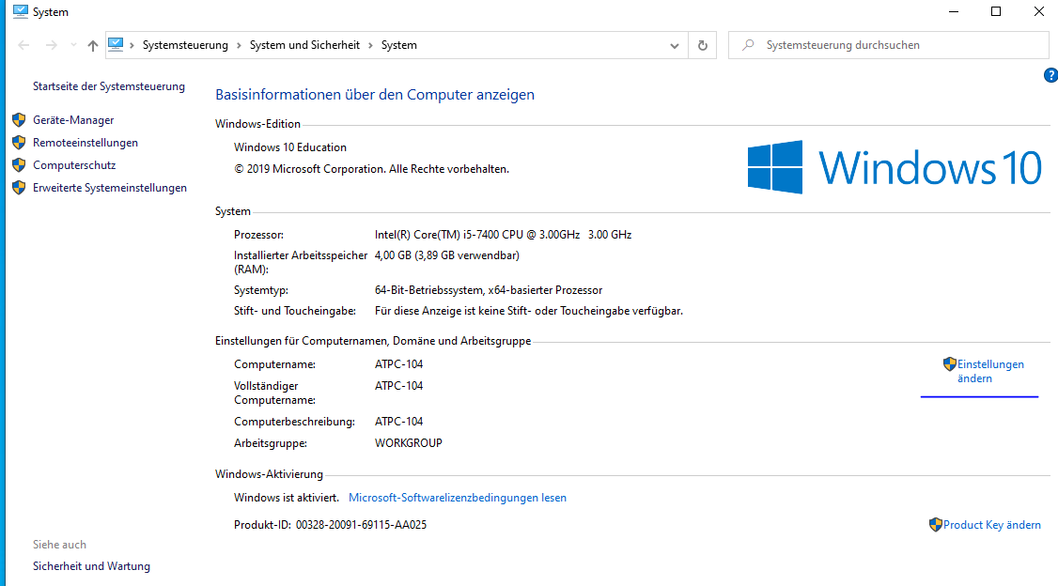

2-5- click on Environment Variables

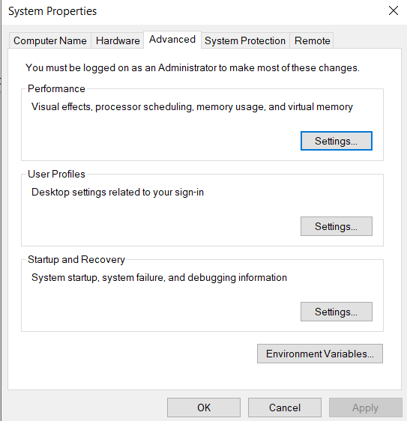

2-6 double click Path

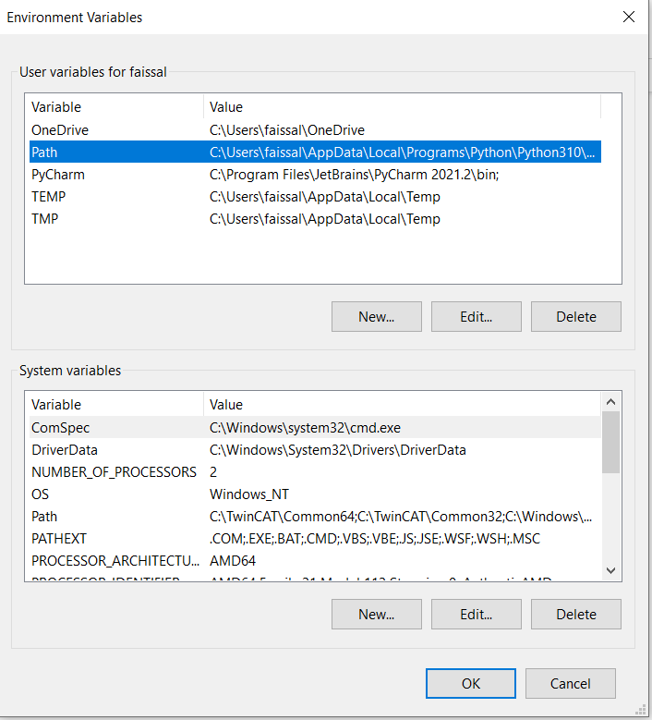

Check if python path exists



If not click new and add

1. C:\Users\YourUsername\AppData\Local\Programs\Python\Python39
2. C:\Users\ YourUsername \AppData\Local\Programs\Python\Python39\Scripts

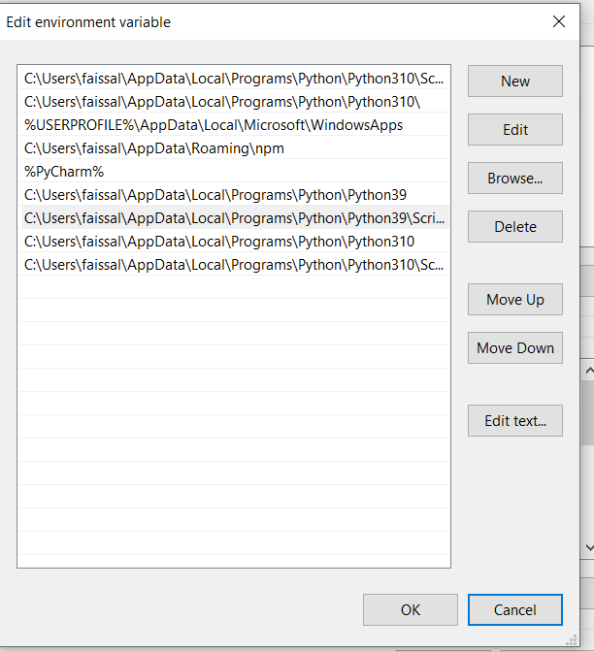

Click OK

Add the 2 paths to the second Path under System variables

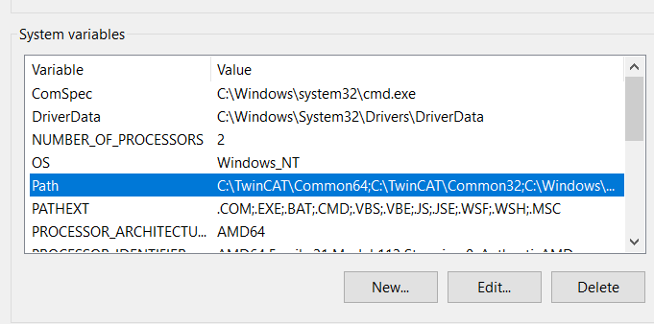

1. Open cmd Windows

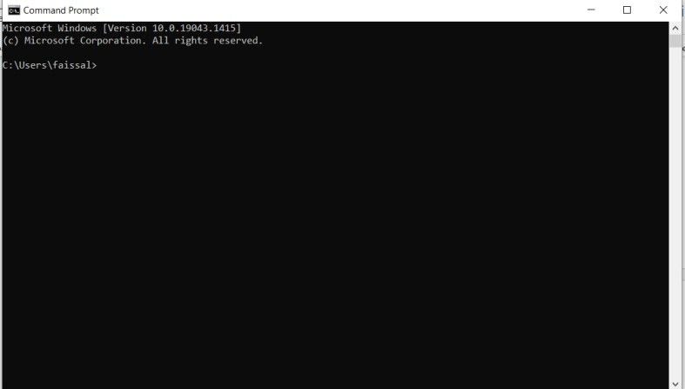

1. Type : python -m pip install opcua ➔ Press Enter

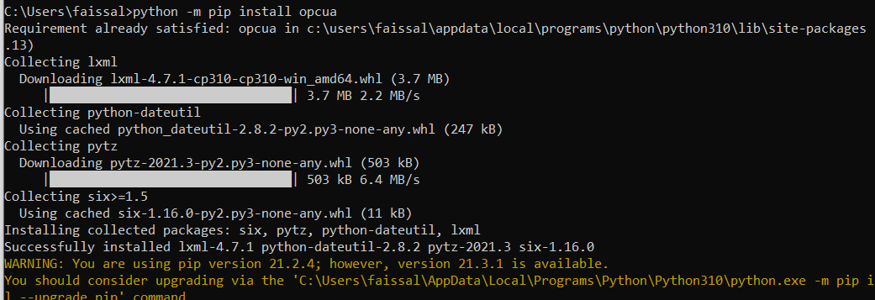

1. Type : python -m pip install cryptography ➔ Press Enter 6-Open The directory of python files

Type: cd C:\Users\Username\<<path>>

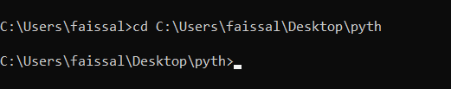

7-Type : python app.py ➔ Press Enter

